Timeline
Site investigation -Contamination
LOT 224 DP 752020 – Gilbert Rd Castel Hill – Pony Club Site

2021 – 29th October
Preliminary site investigation report completed by Geotechnique Pty ltd
- Recommendation for; (page 21)
  - Remediation of ACM impacted soil in the vicinity of the locations as indicated in drawing No 14985/1 – AA3
  - A building hazards material survey be carried out by a professional hygienist … and remediation of the site at and in the vicinity of locations of concern
  - A detailed inspection and sampling should be completed and an asbestos clearance certificate obtained.

2024 - 28th March
Detailed site investigation & remedial action Plan, by Geotechnique Pty ltd
- The same recommendations received as noted above.
- Pg 33; “following completion of the remediation, asbestos clearance inspection must be carried out by NSW Safework licenced Asbestos Assessor.
- Pg 38; “A report will then be prepared on the suitability of the site for the proposed sporting field land use, after completion of remediation.
- Asbestos clearance by an NSW Safework licenced asbestos assessor is required.

2025 – 21st October
- Two x “NO PUBLIC ACCESS” signs erected on Pony Club entry gates, LOT 224 DP 752020
- Barrier tape and “ASBESTOS” warning barrier placed in two areas, in proximity to Area 1 and 2, and area 3 in Drawing No 14985/3 – AA3

2025 – 22nd October
- The 2 “NO PUBLIC ACCESS” signs removed from entry gate.

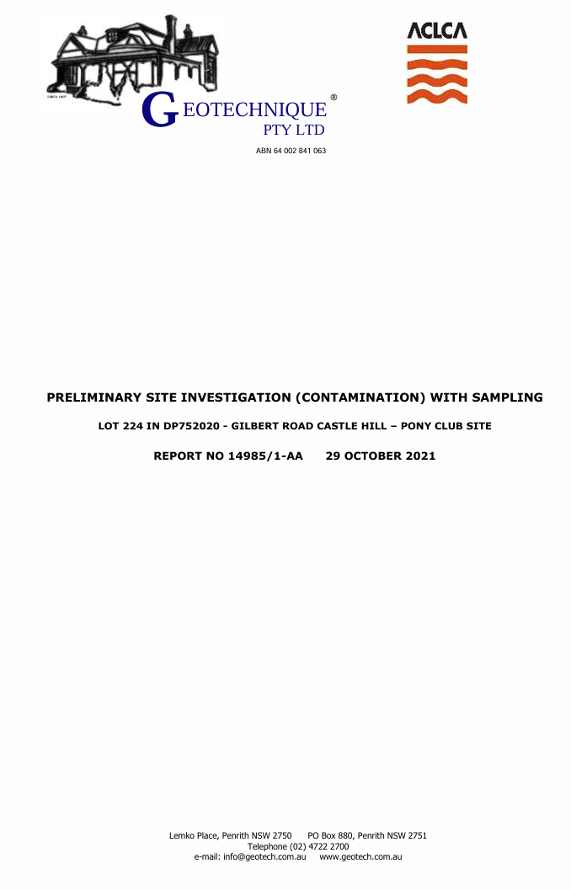
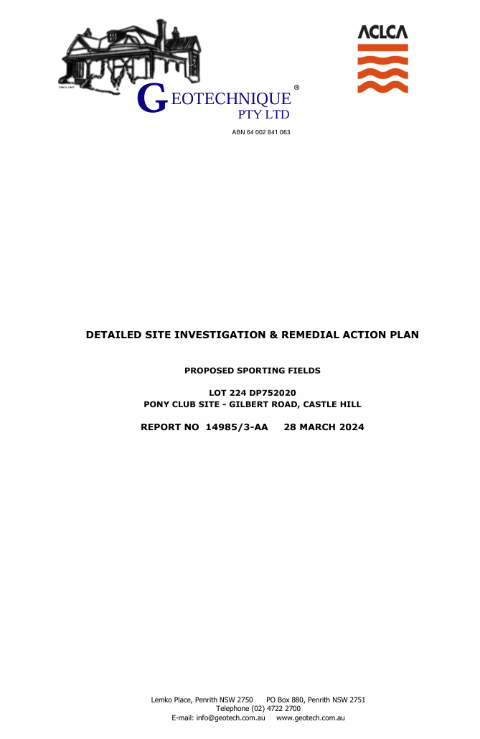
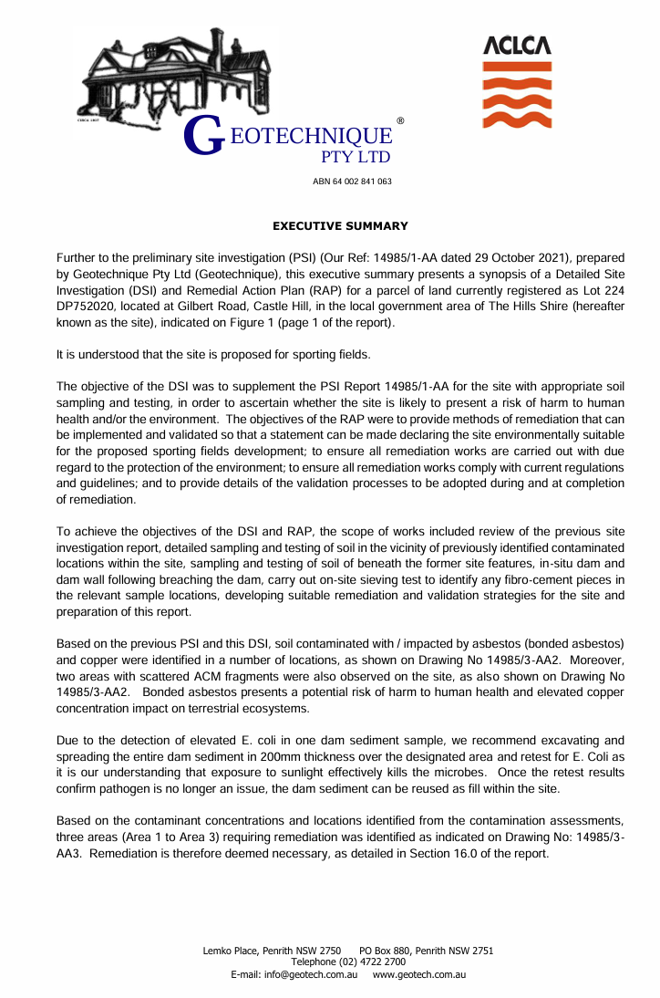

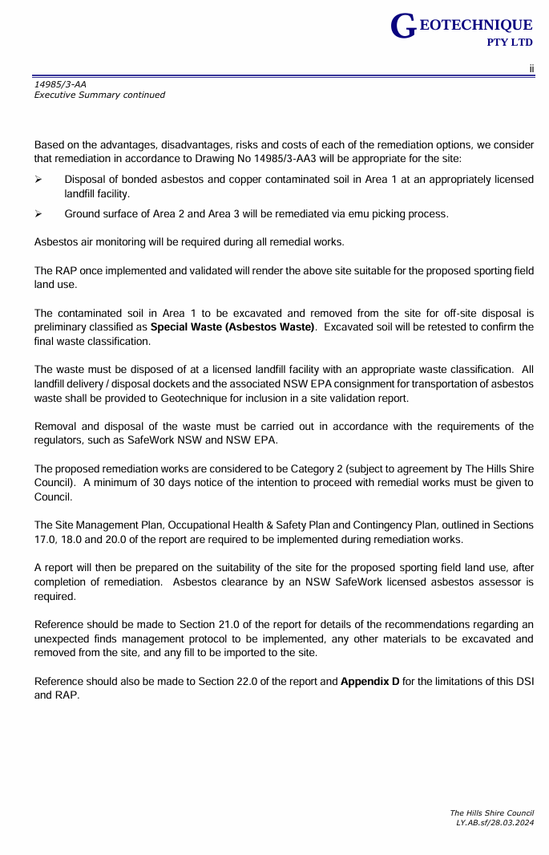
Page 21 (2024)
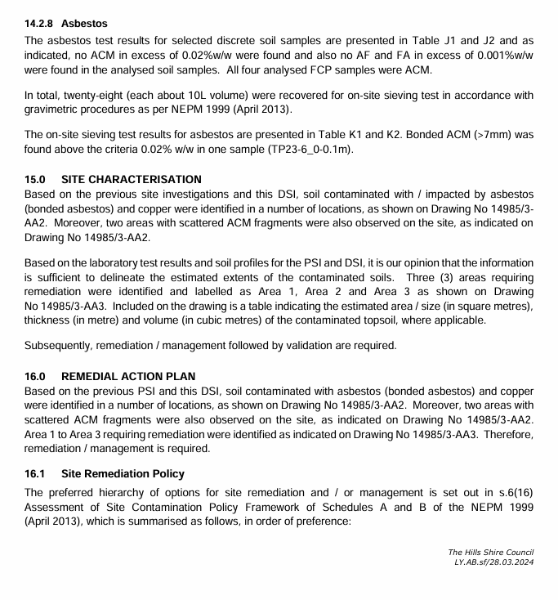

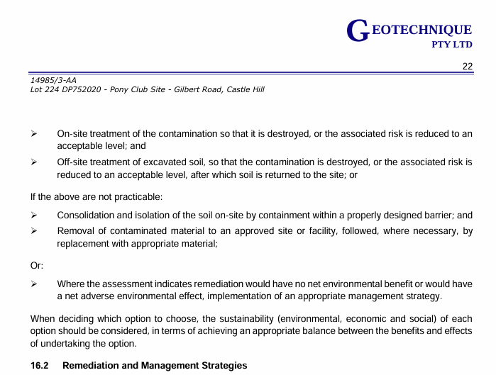

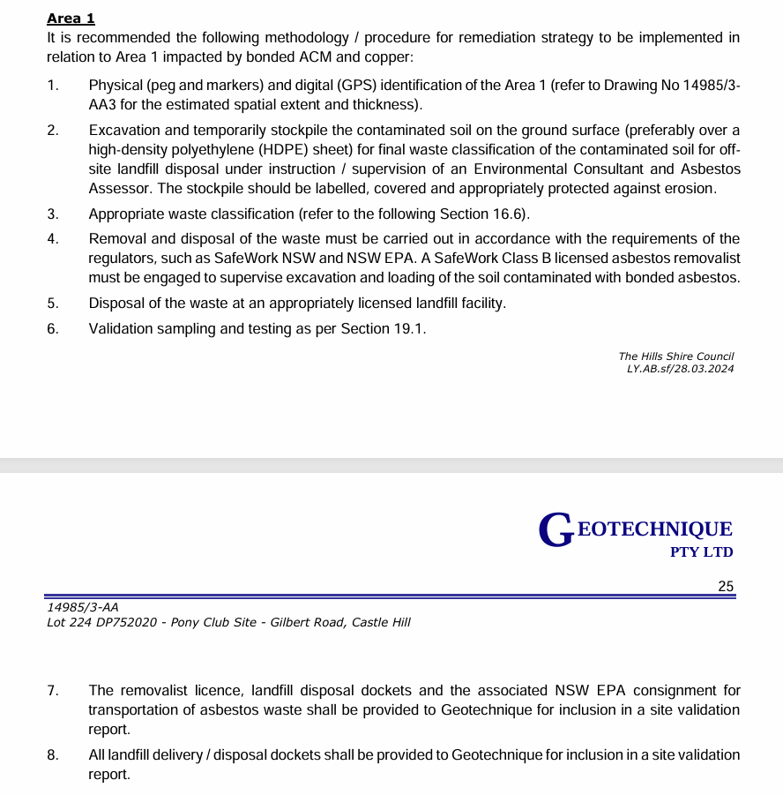

Page 25 (2024)
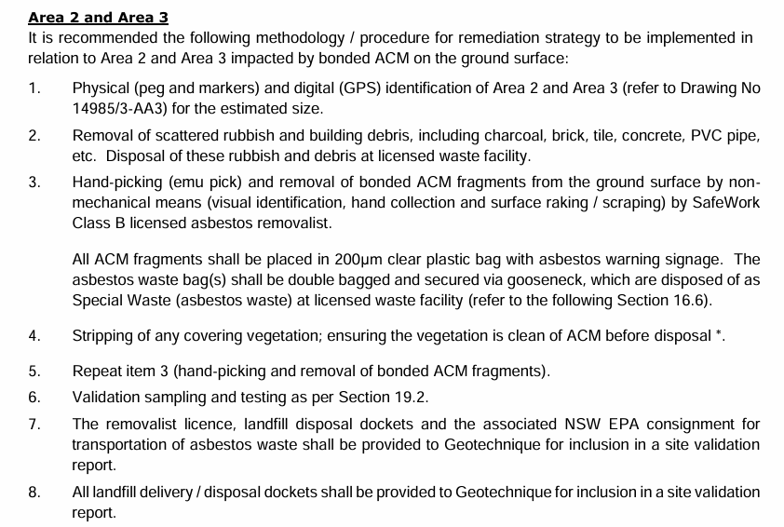

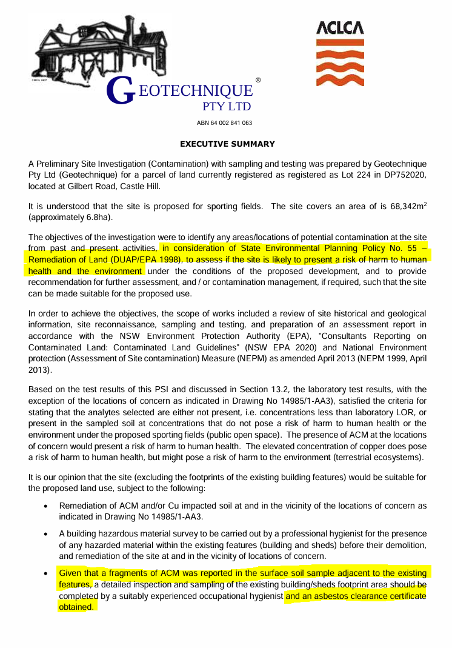
Page (i) (2021)

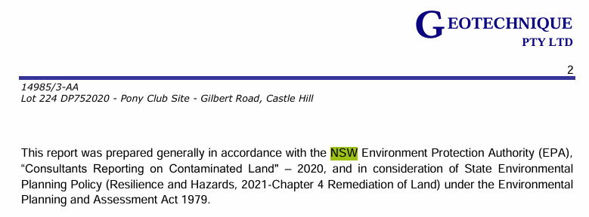
Page 2 (2024)

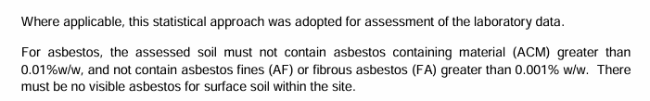
Page 19 (2021)

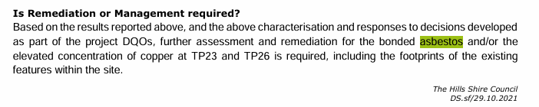
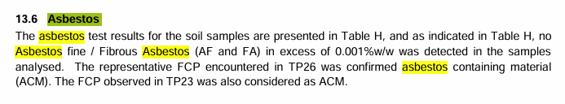
Page 20 (2021)

Page 27 (2021) ACM = Asbestos Containing Material, Identified at Test Pit 23 and 26
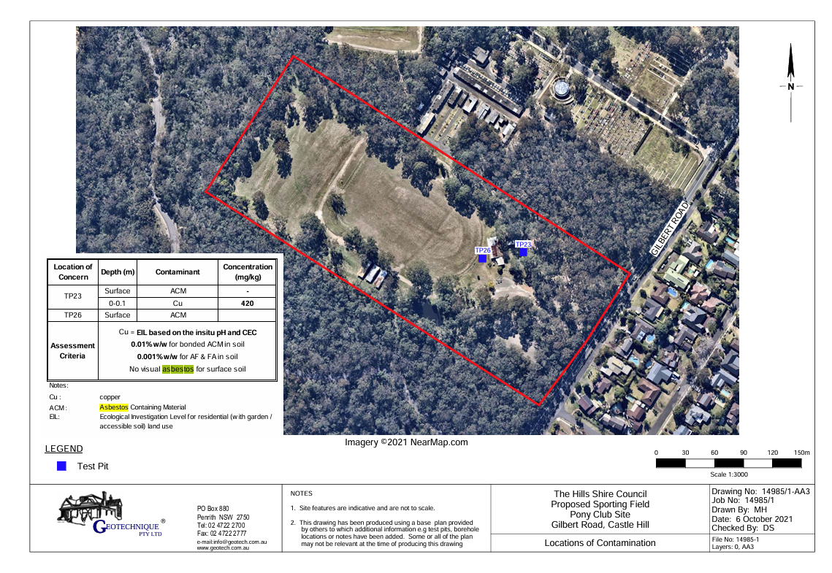
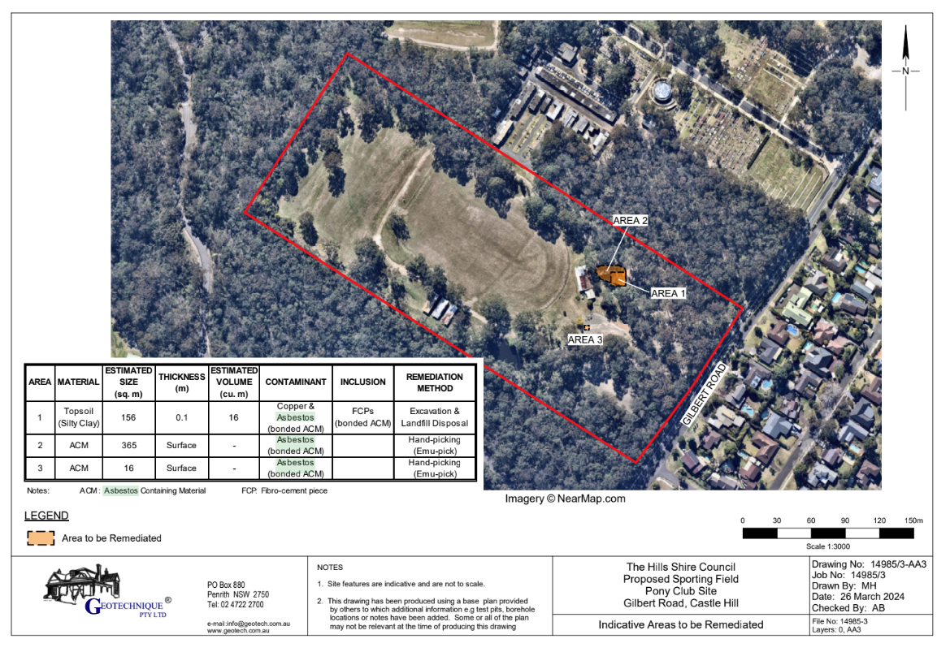
Test pit locations (2024)

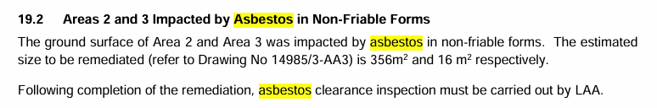
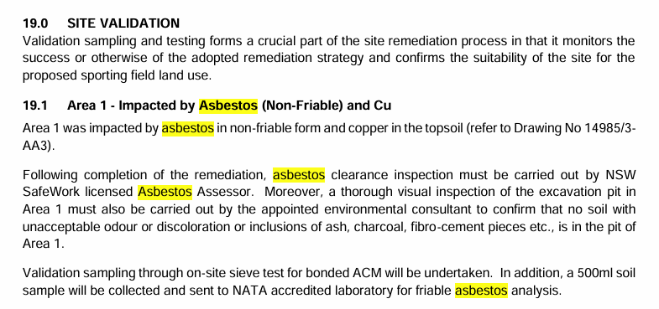
Page 33 & 34 (2024)
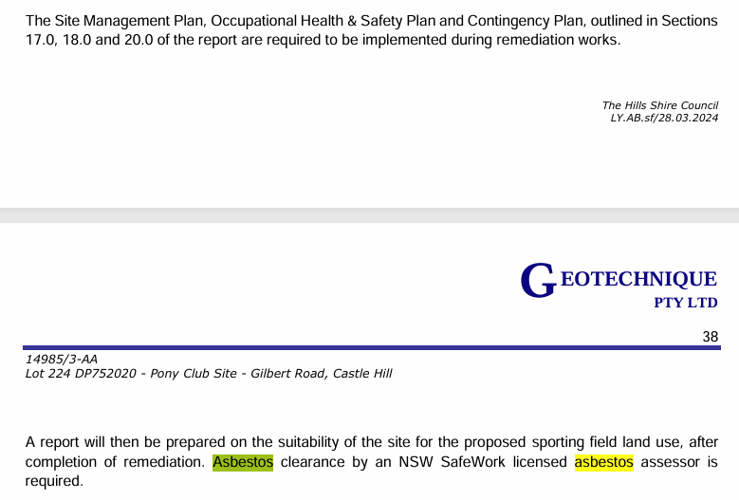
Page 37 & 38 (2024)

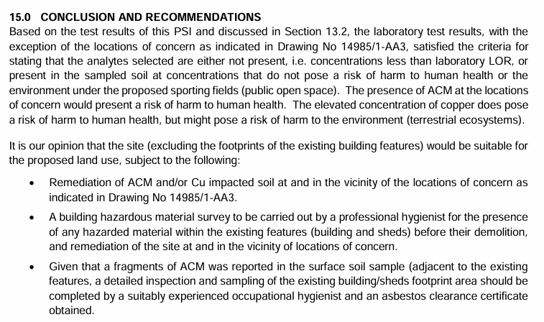
Page 21 (2021)

Page 4 (2024)
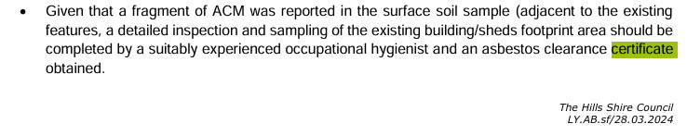
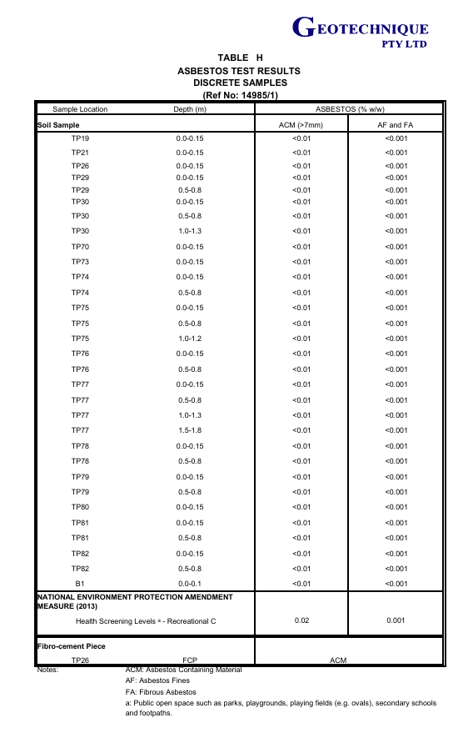
Table H (2021)

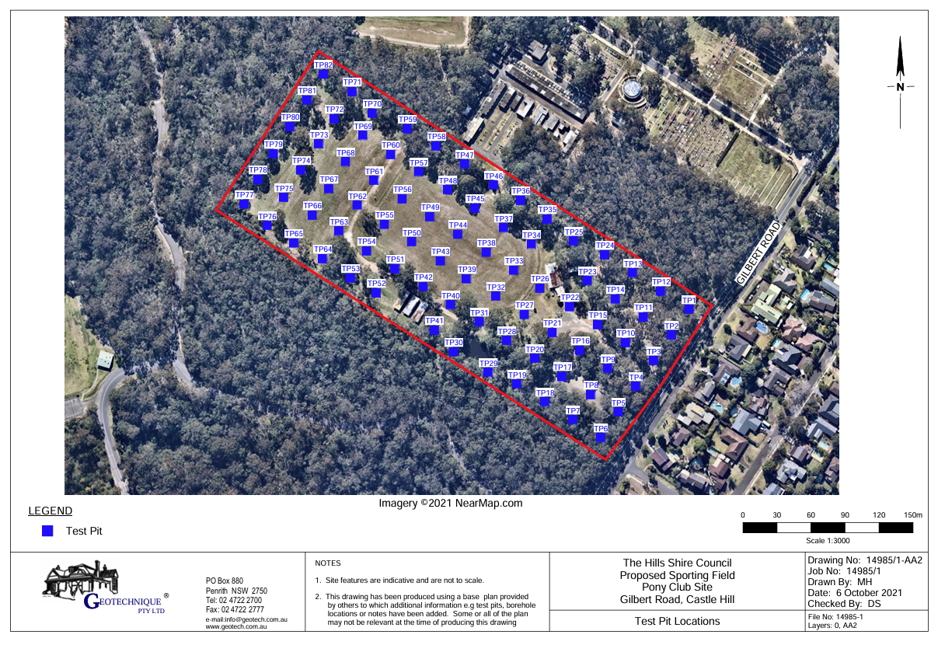
Test Pit locations (2021)

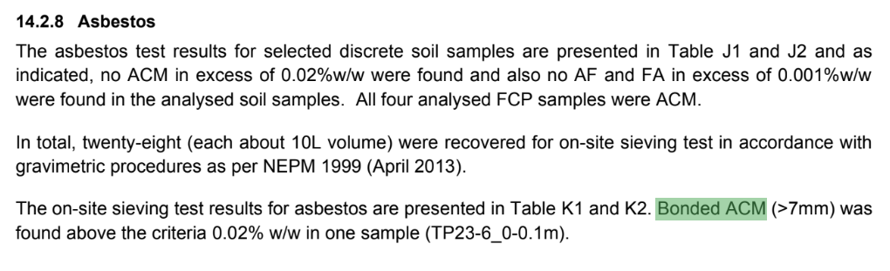

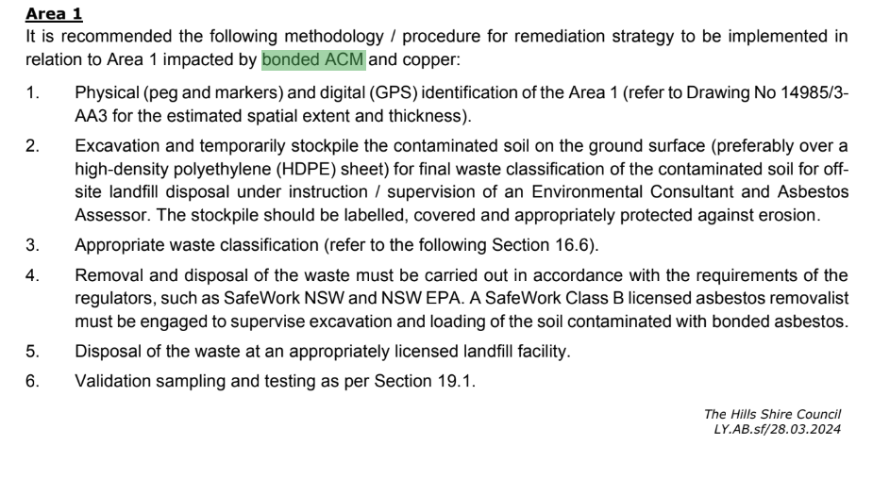
Page 24 & 25 (2024)
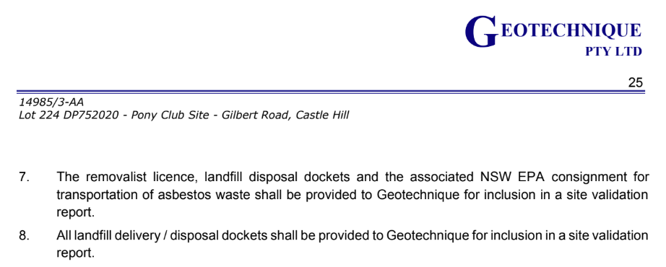
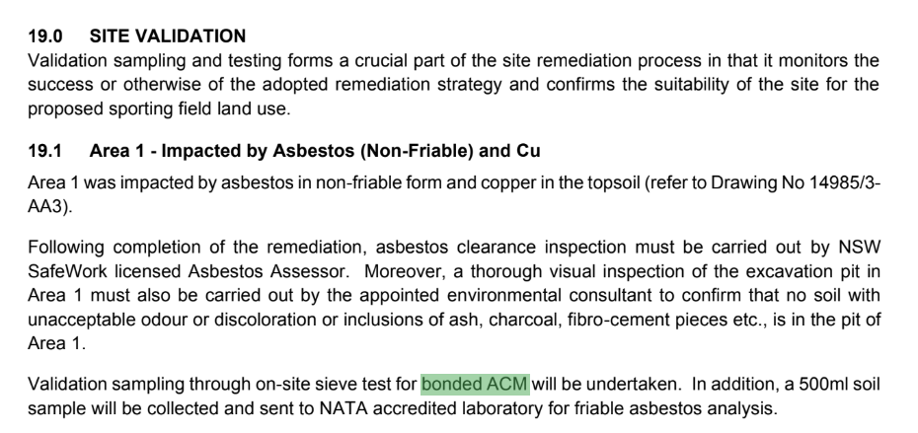
Page 40
